First Lake Water Monitoring Summary Report 2022

The Friends of First Lake Society recognizes the importance of preserving and protecting the First Lake ecosystem, its aquatic species, and the other wildlife it supports. This in turn contributes to the community’s enjoyment of the trails and the recreation opportunities they provide. As a result, water quality testing began in 2021 and continued in 2022 including both water samples sent to the QEII Environmental lab for analysis and field measurements. This was made possible thanks to a generous grant with from Paul Russell, Councillor for District 15. Equipment for testing and training was provided by the equipment bank of the Atlantic Water Network (AWN). The Gordon Foundation supports the public data entry platform, Atlantic Data Stream, which we use.
Our objectives are to:
- Establish and support regular water quality monitoring to identify concerning trends in the lake’s water quality.
- Provide a record of the lake’s water quality over time.
- To foster an interest in the lake ecosystem and community stewardship.

Volunteers: 2-3 volunteers per trip 75.5 volunteer hours 7 sampling days

Volunteers from Friends of First Lake and the local community conducted the testing monthly from May to October.
Volunteers for the 2022 season included, Bruce Batstone, Janey Hughes, David Hughes, Travis Mesher, Alan Tattrie

Equipment

A YSI probe, Secchi disk and Van Dorn sampler were borrowed from the AWN equipment bank. Equipment was borrowed for a two-week sampling period to allow for weather and volunteer availability and picked up and dropped off at AWN office on Young St, Halifax at pre-booked times.
A buoy marked the deep-water testing station on the lake. Thanks to Bruce Batstone for providing us with the buoy, rope, and anchoring device as well as Alan Tattrie for setting the buoy in place.
Many thanks again to Alan Tattrie and Travis Mesher for the use of their boats for testing

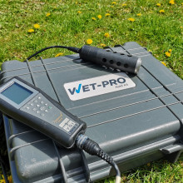
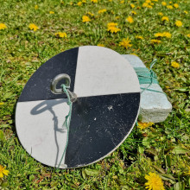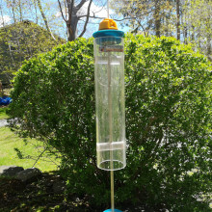
YSI probe: Allows us to take measurements from the surface to the bottom of the lake at specific intervals in the deepest areas of the lake. It measures temperature, dissolved oxygen, conductivity, dissolved solids, salinity, and pH.
Secchi disk: Allows us to get a measure of water clarity and the degree to which light can penetrate the water column.
Van Dorn: Allows us to take water samples at predetermined depths. Grab samples were taken at the deepest area of the lake and at the outlet. All samples were kept cold and delivered to the QEII Environmental lab within 24hrs for analysis of forty-five parameters including metals, nutrients, water chemistry, and chlorophyll a as a marker for algae. E. coli samples were not collected this year to avoid duplication with the HRM Pollution study.

Location: 4 Sample sites

Timing: Approximately monthly from May-October

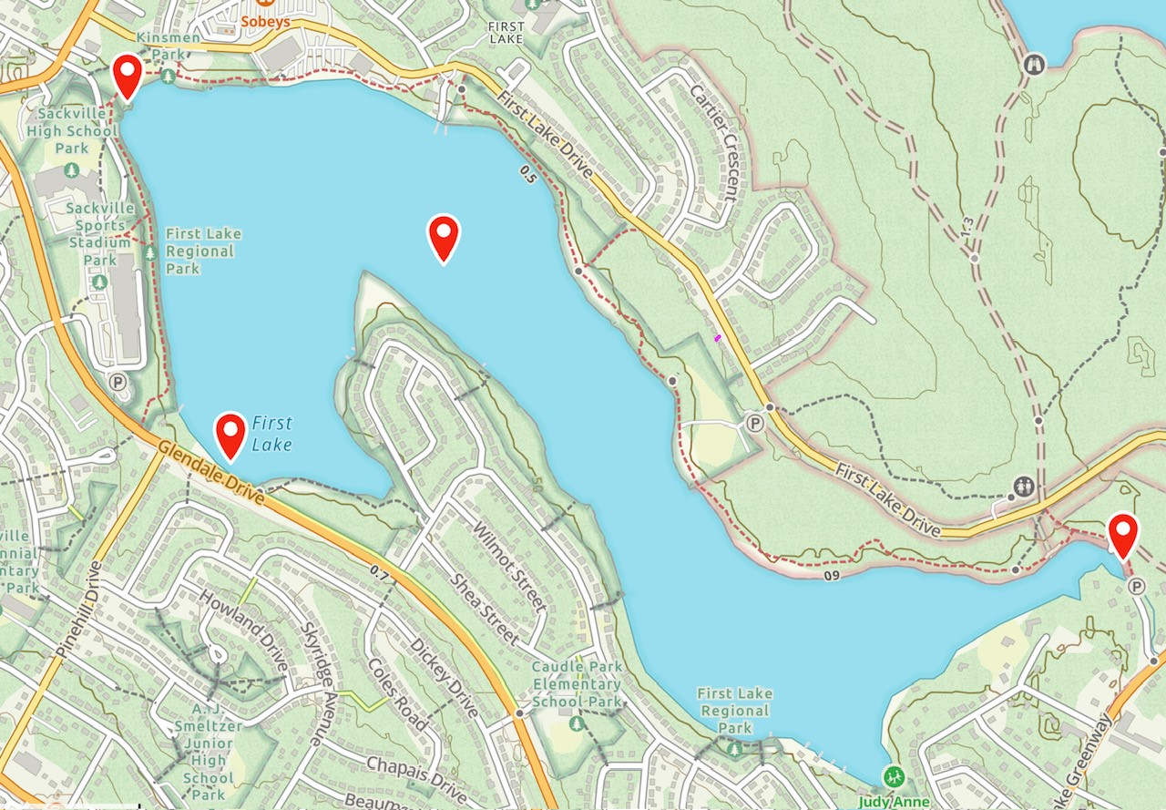

What we tested: 60 grab samples 140 YSI probe measurements

Water Temperature: High water temperature can stress aquatic species and influences what types of fish and other organisms live in the lake.
Dissolved Oxygen: The amount of oxygen available to aquatic species, minimum amounts are required for survival. Levels below 5.5 mg/L will negatively affect most fish.
Conductivity This is the water’s ability to transmit electricity. It is an indicator of the number of dissolved salts in the lake, elevated levels can affect the survival of aquatic species. It is related to the salinity and total dissolved solids in the lake.
Metals: Metals are introduced into water from weathering or erosion of soils and rocks naturally, or at an increased speed due to human activities. Some metals are required in trace amounts by aquatic species others can be toxic to living things. Metals do not break down and can move between water and the sediment in a lake.
pH: A measure of the acidity of the water. Changes to pH might impact the nutrients or toxins in the water. Other water chemistry measures such as alkalinity (the lakes ability to resist changes in pH), hardness (reflects the amount of dissolved calcium and magnesium in water), anions, and cations were also measured.
Dissolved Solids: Dissolved solids can be anything from organic material, to minerals, to pollutants. Too many dissolved solids harm aquatic life and may indicate contaminated runoff.
Nutrients: While some nutrients are healthy, too many nutrients (like phosphorus and nitrogen) can increase algae growth, reduce oxygen levels, and harm ecosystems. Nutrients often come from stormwater and fertilizer in runoff.
Chlorophyll a: A green pigment found in plants, used as a marker for the presence of any type of algae.

Summary of what we found:

All data was entered on the Atlantic Data Stream platform which is publicly accessible. For instructions see below.
All data was compared to the 2006-2011 HRM data and to the Canadian Council of the Ministers of the Environment (CCME) Guidelines for the Protection of Aquatic Life.
- Dissolved oxygen levels showed a consistent pattern of extremely low levels in the lake’s deeper waters in late summer, but levels were starting to increase with the mixing of the warmer upper layers with the cooler deeper areas of the lake in the fall. Normal oxygen levels were observed at all depths in the spring.
- Conductivity was increased in 2022 over 2021 but we had a very dry summer so this may be due in part to evaporation and low lake water levels. We will continue to monitor for trends in this area.
- Most metals were below the lab’s detection limits and below the CCME Guidelines for the Protection of Aquatic Life. There were two notable exceptions; Manganese (Mn) and Iron (Fe) were found to be elevated in mid-September at the bottom of the deepest area of the lake. These metals are part of the natural bedrock in the area. When reviewed with the Nova Scotia’s Department of the Environment, they noted that a good portion of the dissolved Mn and Fe will return to the sediment in a more oxygen rich environment. The remainder will also be diluted with full mixing of the lake with the deep water making up a fairly small percentage of the total lake volume. They also indicated they would be reluctant to apply the CCME guidelines to the deepest part of the lake as they are not tailored to the species that inhabit this area of the lake. Mn and Fe returned to normal levels in October as oxygen levels increased.
- All other parameters were within the normal ranges and the CCME guidelines where those guidelines exist.

For more detailed information please got to atlanticdatastream.ca or contact us at friendsoffirstlake@gmail.com

Atlantic Data Stream

All data can be viewed on Atlantic Data Stream (atlanticdatastream.ca).
Atlantic Data Stream Guide
- Choose “Explore Data” then “Map Search.”
- Type in “Friends of First Lake Water Quality monitoring Data” to bring up the data set.
- Select the Map tab to choose the testing location you would like to view. It is easiest to choose only one at a time. Clear your selection before adding the next location.
- Under the Visualization tab, choose the type of data you want to look at from the drop-down menu listed under Characteristics. Characteristics will only appear in the chart below only if there is data for that characteristic at that testing location. For example, test sites around the perimeter of the lake were only tested for E. coli so that will be the only available characteristic/data.
- The Visualization tab lets you see the data as a graph. The Statistics tab displays information in a table.
- The Explainer tab will provide an explanation for the Characteristics (if available).

Many thanks to:

Councillor Paul Russell- District 15

