E. Coli Stormwater Outfalls
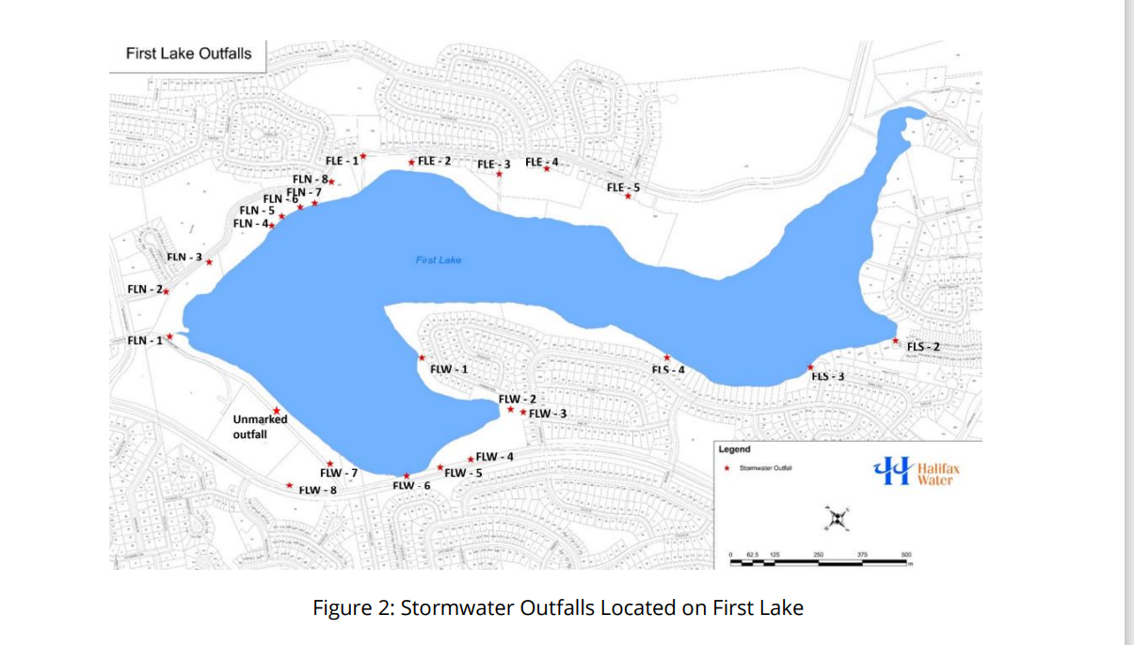

Site | Rainfall  (mm) | FLN-8 | FLW-1 | FLW-2 | FLW-3 | FLW-8 | FLS-3 | Inlet (Kingfisher Pumping Station)
Jul-22 | Dry | 9,691 | 20,000 | 20,000 | 5,377 | 20,000 | 13,064 | 328
Aug-22 | Dry | 515 | 26,877 | 9,218 | 20,000 | 3,498 | 265 | 400
Sep-22 | 10.8 | 10,589 | 2,500 | 1,715 | 25,000 | 9,177 | 25,000 | 500
Aug-23 | 26.5 | 10,000 | 12,000 | 9,000 | 7,000 | 9,000 | 8,000 | 13,000
Oct-23 | 23.5 | NA | 4,000 | 1,00 | 6,000 | 1,000 | 5,000 | 1,000
May-24 | 50.1 | 2,000 | 14,000 | 10,000 | 3,000 | 8,000 | ND | 11,000
E. Coli in CFU/100 mL. Rainfall in previous 24 hours.

